

PROJECT 2 (PRT262S)
Problem Definition and Requirements

EduFinance Hub

Name | Surname | Student Number
Thaakierah | Mohamed | 250032376
Deen | Mohamed | 220442010
IVA | MLAMBO | 250133776
PALESA | MLANGENI | 223129410
MFUNDO | MNGUNI | 250892316
LEBOGANG | MOEPENG | 250375869

Contents
1.Problem Definition 3
2.Needs of the client 4
3.System Considerations 4
4. System Overview 4
5. Functional Requirements 5
6. Non Functional Requirements 6
7. Requirement Prioritisation 6
8. Technical Requirements 7
9.Scope of the project 8
10.Communication Strategy 9
11.Task Allocation 10
12.Group Organisation 10
13. Minutes of the meeting 11
14. Conclusion 13

1.Problem Definition
The increasing cost of education in South Africa has made access to financial support a critical challenge for students, particularly those from disadvantaged and first-generation backgrounds. Majority of students are aware of government bursaries such as NSFAS and Funza Lusaka. Even with bursaries and scholarships available, numerous students are either uninformed about these options or do not have the proper guidance to apply effectively.
In addition, Funding information is frequently dispersed over various platforms, making it difficult to access as well as making it difficult for students to get accurate and relevant information. As a result, this causes students to miss deadlines or submit incomplete applications. In addition, many students face difficulty in managing finances because of limited financial literacy, poor budgeting skills, and lack of planning tools, resulting in financial pressure and negatively impacting academic performance.
The problem can therefore be defined as the difficulty students face in accessing, applying for, and managing funding opportunities due to disjointed information systems, lack of structured support, and limited financial literacy.
If these challenges are not addressed, students may miss funding opportunities, experience increased financial stress and potentially face academic failure or dropout due to financial constraints.
To address these challenges, this project proposes the development of Edu Finance Hub, a mobile platform that centralises funding opportunities, provides application guidance, and supports financial management.
The system will target Grade 12 learners, university and TVET students, as well as first-generation students requiring financial guidance.

2.Needs of the client
Students require a system that:
- Provides access to both government and private bursaries
- Assist in application process
- Sends reminders for deadlines
- Assist with expense tracking and budgeting
- Improves financial literacy through educational content

3.System Considerations
3.1Compatibility
The system needs to ensure compatibility with Android and iOS platform. It should also function properly with different screen size and low-end devices. In addition to this, it needs to ensure compatibility with low internet connectivity.
3.2 Performance
The system needs to ensure that it performs its functions with ease. This includes providing users withy quick responses to their querier and providing users with smooth user interface.
3.3 Boundaries
The system will not provide direct funding or act as a banking platform. It will rely on external sources for bursary information and requires users to have access to a mobile device and internet connection.

4. System Overview
EduFinance Hub is a student centred digital platform that combines funding discovery, application support and personal financial management into a single platform
The system aims to improve access to available funds, improve the chances of successful applications and improve financial literacy and budgeting behaviour.
The system will target Grade 12 learners, university and TVET students, as well as first-generation students requiring financial guidance

5. Functional Requirements
5.1 User Management
- The system will allow users to securely register and log in securely
- The system will allow users to create personal profiles
- The system will store academic and financial information for matching purposes

5.2 Funding Discovery & Matching
- The system will allow users to search for bursaries and scholarships
- The system will allow users to filter bursaries and scholarship opportunities based on the user profile
- The system will recommend suitable funding options to users based on eligibility criteria

5.3 Application Support
- The system will guide users step by step in the application process
- The system will generate a document checklist for each application to ensure that all requirements are met
- The system will notify users of missing or incomplete requirements

5.4 Notifications and Reminders
- The system will send deadline reminders for funding applications
- The system will notify users of new opportunities
- The system will provide alerts for upcoming submissions

5.5 Financial Management
- The system will record and track daily expenses using the application
- The system will allow users to create monthly budgets
- The system will provide information to users to help them understand their expenses
- The system will allow users to set and track savings goals

5.6 Financial Literacy
- The system will provide tips and educational content on financial management
- The system will provide guidance on spending and saving

6. Non Functional Requirements
6.1 Usability
- The system will be user friendly, easy to navigate and provide an intuitive user interface for users with basic digital literacy
6.2 Performance
- The system will respond to errors within seconds
- The system will be capable of supporting multiple users simultaneously

6.3 Security
- The system will protect user data through secure authentication
- The system will ensure confidentiality of user personal and financial data
6.4 Reliability
- The system will be able to cope with errors and operate consistently without any loss of data

6.5 Compatibility
- The system will be compatible with Android and IOS devices and function across different device types

7. Requirement Prioritisation
High Priority:
- Funding discovery
- Funding Matching
- Application support
- Notifications and reminders
Medium Priority:
- Financial Management Features like budgeting and expense tracking
Low Priority
- Financial Literacy content

8. Technical Requirements
The system will be implemented in the form of a mobile application, and the mobile-first approach will be employed in the design and development of application. The application will have users authentication, databases database for storing user and bursary information, and internet-based functionality for real-time updates. The system must also be scalable to support future growth and additional features.

9.Scope of the project
9.1 Project scope overview
The scope of this project defines the boundaries and extent of the proposed system, EduFinance Hub, which is a mobile-based platform designed to assist students in accessing funding opportunities and managing their finances effectively.
The system will focus on improving:
- Access to bursaries and scholarships
- Application support and guidance
- Student financial management and literacy
The scope outlines what the system will include (in-scope) and what it will not include (out-of-scope) to ensure clarity and feasibility.

9.2 In Scope (What the system will do)
The EduFinance Hub system will include the following core functionalities:
- Access to government and private bursaries
- Bursary matching system
- Application guidance and reminders
- Expense tracking and budgeting tools
- Financial literacy resources
9.3 Out of Scope (What the system will not do)
To maintain focus and ensure feasibility, the following will NOT be included:
- Processing or approving funding applications
- Direct integration with external funding institutions
- Handling real financial transactions
- Advanced financial advisory services
- Full integration with university systems
9.4 Target Users
The system will be designed for:
- Grade 12 learners preparing for tertiary education
- University students
- TVET students
- First-generation students requiring financial guidance

9.5 System Boundaries
The system will operate as a standalone mobile application, where:
- Users interact directly with the system through a user interface
- The system retrieves and displays funding information
- No external systems will be directly integrated
9.6 Assumptions
The project is based on the following assumptions:
- Users have access to smartphones and internet connectivity
- Users have basic digital skills
- Bursary data is sourced from external providers
- Users will input accurate personal and financial data
- Funding information can be sourced and updated manually
9.7 Constraints
The system development may be limited by:
- Limited internet connectivity for some users
- Lack of time and resources
- Lack of accuracy in the database
- Limited access to real funding databases

10.Communication Strategy
Effective communication is ensure the project success. The group will use the following communication methods to complete this project:
- WhatsApp Group: This is for daily communication, quick updates as well as reminders
- Blackboard Group tools: For Submitting work and tracking progress
- WhatsApp group calls: to check up on members progress and discuss what more needs to be done for the project
Weekly meetings will be held to make sure each member is caught up and s is on track . Issues will be discussed as a group and if unresolved group leader will make the final decision.

11.Task Allocation
Member | Role | Responsibilities
Palesa Mlangeni | Group Leader | manages team and progress
Thaakierah Mohamed | System Analyst | Problem definition, requirements, documentation
Deen Mohamed | Researcher | Gathers information and supports analysis
Iva Mlambo | Content Developer | creates system content
Mfundo Mnguni | Documentation Manager | handles report & formatting
Lebogang Moepeng | System designer | designs system structure

12.Group Organisation
Group is structured to ensure smooth coordination:
- Group Leader: Oversees the project and ensures deadlines are met
- Scribe: Responsible for recording meeting minutes and uploading to Blackboard
- Team Members: Each member is responsible for their allocated tasks
Decision-Making:
- Decisions will be made through group discussions
Meetings:
- Minutes of all meetings will be recorded and uploaded as required

13. Minutes of the meeting
Meeting 1
Date: 10 March 2026
Time: 20:01 pm
Duration: 28 minutes 37 seconds
Platform: WhatsApp Call
Initiated by: Palesa Mlangeni (Project Leader)
Attendees: All group members present

Agenda:
- Discussion of the project brief
- Allocation of the project roles
- Discussion of the submission requirements
Discussion:
The meeting commenced with all the group members present. The project brief was shared and discussed in detail to ensure that members had a clear understanding of the project requirements and specifications. Next the discussion the project brief was then finalised and agreed upon by all members.
Project roles were then defined. The group also discussed submission requirements, including deadlines and the format of submission.

Decisions made:
- The project brief was finalised and approved by all members.
- Roles were defined
- Submission requirements and expectations were agreed upon

Evidence of our first group meeting showing date, time and participant below.
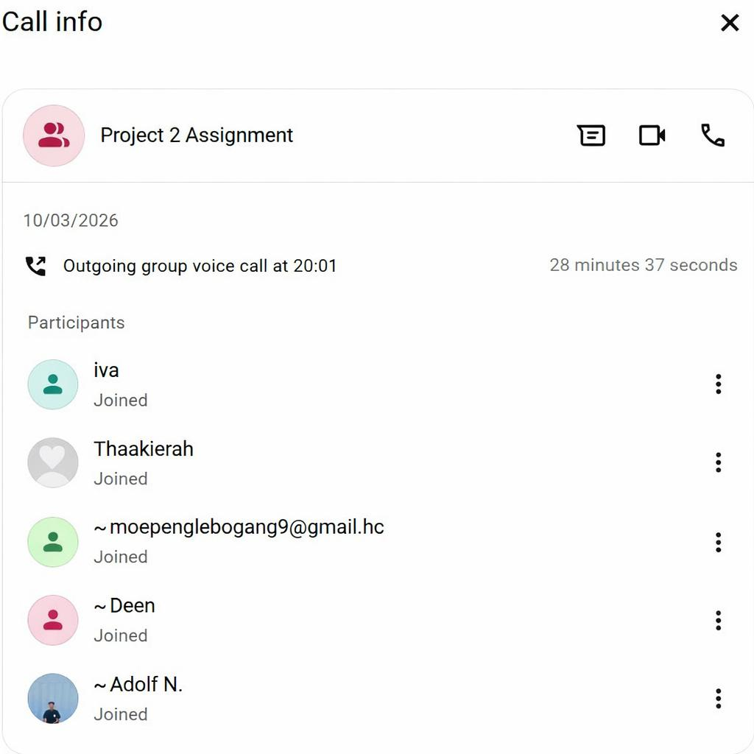

Meeting 2
Date: 18 March 2026
Time: 17:06 pm
Duration: 28 minutes 48 seconds
Initiated by: Palesa Mlangeni (Project Leader)
Platform: WhatsApp call
Attendees: All group members present

Agenda:
- Finalisation of project roles
- Discussion of responsibilities
- Confirmation of due dates
Discussion:
The primary focus of the meeting was to review and finalise the roles and assign each member a role. After discussion all the roles were confirmed and agreed upon.
Responsibilities associated with each of the roles were discussed to ensure that all members clearly understood their individual tasks and contributions to the project.
The group also discussed the project due date to ensure alignment and proper planning.
Decisions made:
- Project roles were finalised and agreed upon by all members
- Responsibilities for each role was clearly defined
- The project due date was confirmed and acknowledged by all members

Evidence of our second group meeting showing date, time and participant below.

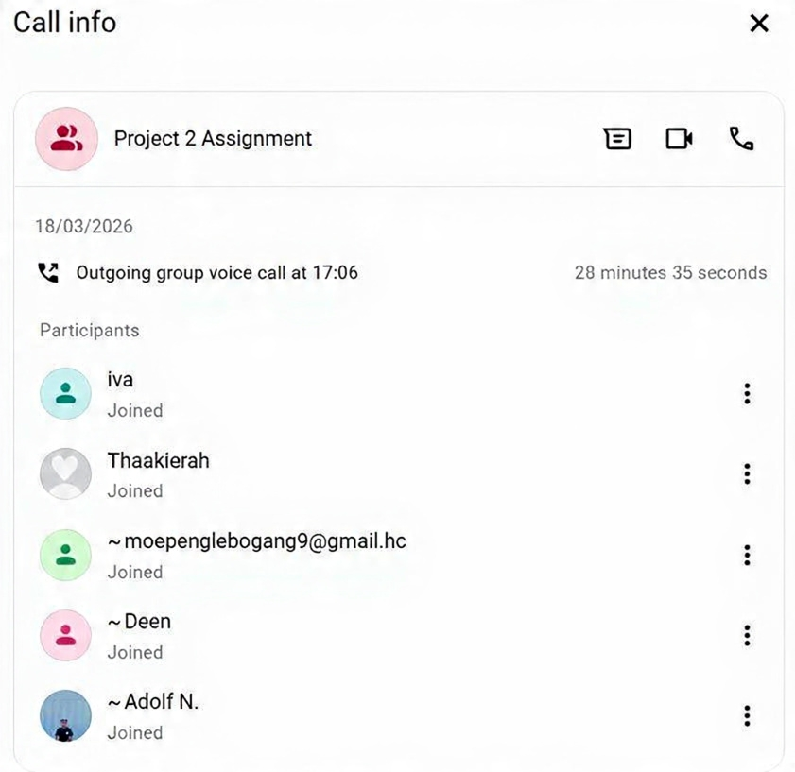

14. Conclusion
In conclusion, this initiative tackles the essential issues that South African students encounter in obtaining funding opportunities and handling their finances with the suggested EduFinance Hub system. EduFinance Hub serves as a centralized, easy-to-use mobile platform that streamlines the process of finding bursaries and scholarships, offers organized guidance for applications, and enhances financial literacy with useful budgeting tools. The system enhances awareness of government and private funding options, simplifies the application procedure, and promotes prudent financial management, thereby supporting academic achievement and financial health. Additionally, by addressing challenges like fragmented information, insufficient application support, and inadequate financial literacy, EduFinance Hub offers a realistic and viable solution within its established framework. Despite some limitations, including the absence of direct integration with funding organizations, the system holds considerable promise for alleviating financial pressure and substantially enhancing overall student results.

